TEMPLATE FOR CP FULL AUDIT REPORT

General considerations and recommendations for writing the summary report.
Language | The report is first and foremost for the FSP management. Therefore, if possible, it should initially be written in the native language used by the staff of the FSP; if that is not possible, it may be written in English provided the staff are comfortable with it. After the report has been vetted internally, it can be translated into English to facilitate sharing the results with other stakeholders, networks, investors, and other external parties. Cerise+SPTF encourages auditors to provide a copy in both languages.
Organization | The summary should be well structured, to facilitate easy and fast reading.
Pictures (Optional) | Blocks of text are impersonal and not very tempting to read. Pictures of clients and the FSP staff give the reader a glimpse of reality.
Length | It’s a summary, not a detailed report! Focus on the most important information. The reader wants a quick overview of the FSP’s results.
Audience | Remember the different people who will read the summary (investors, microfinance experts, practitioners, networks, TA-providers, general public) and tailor your prose to what they need to know.
Version | 001 – 2026
Date | 18 January 2026

Communication strategy of SPI results and summary
- Ask for FSP management to validate the summary.
- Encourage the FSP to disseminate the summary or abstracts of it to:
- Internal stakeholders: board of directors, staff, clients
- External stakeholders: donors, investors, technical assistance providers, partner organizations, parent organization
- Local and regional networks
Etc…



Client Protection Audit REPORT
Name of FSP, Country

<Logo of auditing organization>



Audit team:
xxxxxxxxxx – Lead Auditor
xxxxxxxxxx – Trainee auditor
xxxxxxxxxx – Trainee Auditor
xxxxxxxxxx – Analyst
xxxxxxxxxx - Translation

[ Month Year]

© The information contained in this document is confidential and privileged, intended solely for the use of the designated recipient. It may not be used, published, or redistributed without the prior written consent of xxxxxxxxxxxxxxxxxxxx. Any reproduction or redistribution of this document must retain the original logos and attributions to xxxxxxxxxxxxxxxxxxxx. If you are not the intended recipient, you are hereby notified that any disclosure, copying, distribution, or use of this information is strictly prohibited.

Client Protection Audit Report
[Name of FSP]
[Country, Month Year]

Introduction
Summarize the organization’s approach and reasons for applying Client Protection Audit in a few sentences.

The audit was conducted based on the Cerise+SPTF Client Protection Standards framework, using the SPI online/ CP Full audit tool, which highlights the FSPs strengths and weaknesses in client protection, and aims to provide clear insight in the gaps and elements that need attention for improved management systems and practices over time.
The audit started with a desk review of key documents and materials such as the FSP’s policies and procedures, national context, and financial data as they relate to the CP standards. Following the desk review, a field visit was conducted to confirm compliance or non-compliance and provide evidence.
This report is a summary of the key results of the audit, as well as recommended steps and should be reviewed alongside the full audit tool.

Description of the Financial Institution and local context
Provide a brief description of the financial institution giving details not contained in the Introduction above, including mission and vision, social objectives, Governance and Management, areas of operations, methodology and services provided (financial and non-financial). Describe the FSP’s context, history and any particularities. Please mention any key partners, affiliations or parent organization.



Table#: Key Financial Indicators

The table should show the key indicators of the last 3 years at least

CP Full audit dashboard

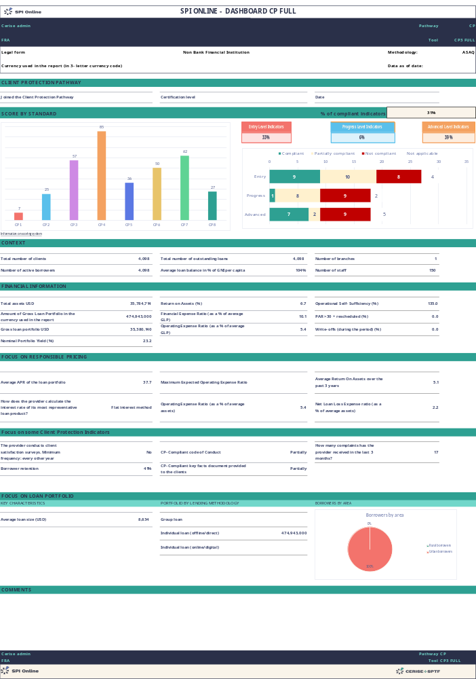

Audit results on Client Protection Standards

Standard 1: The Provider’s products, services and channels benefit clients (7%)
Essential Practices:
1.1 The provider uses data to identify patterns of financial behaviour by client segment
1.2 The provider collects client feedback on their experiences using the provider's products and services
1.3 The provider uses insights from client data to design products, services, and delivery channels
1.4 The provider's products, services, and channels protect clients from harm

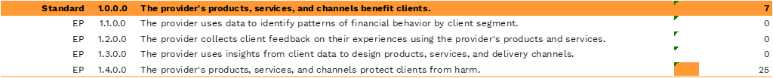

Summarize the FSP’s activities and efforts to date in addressing the EPs in standard 1.
Start with the positive results, i.e., those indicators on which the FSP obtained a (very) good score. Mention special efforts or circumstances that explain why the FSP obtained these results and if there are any initiatives pending whose implementation will influence this score in the near future.

Areas for improvement /recommendations:
Conclude with recommendations and areas of improvement i.e. those indicators for which the FSP did not obtain a good score. Either address each of the indicators in separate paragraphs or summarize the whole Standard in one paragraph.

Standard 2: The Provider does not over-indebt clients (25%)
Essential Practices:
2.1 The provider makes loan decisions based on a client’s repayment capacity
2.2 The provider monitors the market and responds to heightened over-indebtedness risk
2.3 The provider’s strategic and/or business plan establishes responsible growth targets
2.4 During times of high growth, the provider monitors more frequently data related to responsible growth

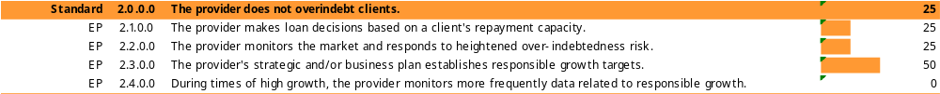

Summarize the FSP’s activities and efforts to date in addressing the EPs in standard 2.

Areas for improvement /recommendations:
Conclude with recommendations and areas of improvement

Standard 3: The Provider gives clients clear and timely information to support client decision making (57%)
Essential Practices:
3.1 The provider is transparent about product terms, conditions, and pricing
3.2 The provider communicates with clients at appropriate times and through appropriate channels

Summarize the FSP’s activities and efforts to date in addressing the EPs in standard 3.

Areas for improvement /recommendations:
Conclude with recommendations and areas of improvement

Standard 4: The Provider sets prices responsibly (85%)
Essential Practices:
4.1 The provider charges fair prices
4.2 The provider charges reasonable fees
4.3 The provider does not transfer unnecessary costs to clients

Summarize the FSP’s activities and efforts to date in addressing the EPs in standard 4.

Areas for improvement /recommendations:
Conclude with recommendations and areas of improvement

Standard 5: The Provider enforces fair and respectful treatment of clients (36%)
Essential Practices:
5.1 During the recruitment and hiring process, the provider assesses each candidate’s commitment to achieving the provider’s social goals and serving its target clients
5.2 The provider’s code of conduct requires fair and respectful treatment of clients
5.3 The provider does not use aggressive sales techniques
5.4 The provider protects clients’ rights to respectful treatment during the loan collection process

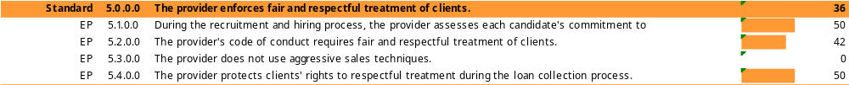

Summarize the FSP’s activities and efforts to date in addressing the EPs in standard 5.

Areas for improvement /recommendations:
Conclude with recommendations and areas of improvement

Standard 6: The Provider secures client data and informs clients about their data rights (50%)
Essential Practices:
6.1 The provider maintains the security and confidentiality of client data.
6.2The provider informs clients about data privacy and data rights

Summarize the FSP’s activities and efforts to date in addressing the EPs in standard 6.

Areas for improvement /recommendations:
Conclude with recommendations and areas of improvement

Standard 7: The Provider receives and resolves client complaints (58%)

Essential Practices:
7.1 The provider has a complaints mechanism that is easily accessible to clients and adapted to their needs.
7.2 The provider resolves complaints efficiently
7.3 The provider uses information from complaints to manage operations and improve product and service quality

Summarize the FSP’s activities and efforts to date in addressing the EPs in standard 7.

Areas for improvement /recommendations:
Conclude with recommendations and areas of improvement

Standard 8: The governance and management are committed to client protection, and IA and HR systems support its implementation (27%)

Essential Practices:
8.1 The Board makes strategic decisions based on social and financial data
8.2 Management makes strategic and operational decisions based on social and financial data
8.3 The provider trains all employees on its social goals and on client protection
8.4 The provider evaluates and incentivises employees based on social and financial criteria

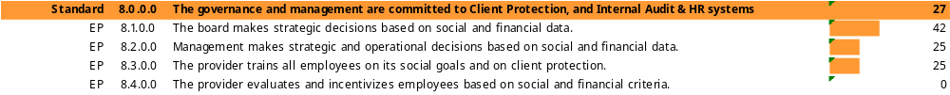

Summarize the FSP’s activities and efforts to date in addressing the EPs in standard 8.

Areas for improvement /recommendations:
Conclude with recommendations and areas of improvement

GAP Analysis (Summary of the SPI5 Audit Tool on CP – See SPI online or spiflat export for detailed insights)
Standard | Essential Practice | Key results
Appropriate Product Design & Delivery | The provider uses data to identify patterns of financial behaviour by client segment | - xxxxxxxxxxxx  + xxxxxxxxxxxx
Appropriate Product Design & Delivery | The provider collects client feedback on their experiences using the provider's products and services | - xxxxxxxxxxxx  + xxxxxxxxxxxx
Appropriate Product Design & Delivery | The provider uses insights from client data to design products, services, and delivery channels | - xxxxxxxxxxxx  + xxxxxxxxxxxx
Appropriate Product Design & Delivery | The provider's products, services, and channels protect clients from harm | - xxxxxxxxxxxx  + xxxxxxxxxxxx
Prevention of Over-indebtedness | The provider makes loan decisions based on a client’s repayment capacity | - xxxxxxxxxxxx  + xxxxxxxxxxxx
Prevention of Over-indebtedness | The provider monitors the market and responds to heightened over-indebtedness risk | - xxxxxxxxxxxx  + xxxxxxxxxxxx
Prevention of Over-indebtedness | The provider’s strategic and/or business plan establishes responsible growth targets | - xxxxxxxxxxxx  + xxxxxxxxxxxx
Prevention of Over-indebtedness | During times of high growth, the provider monitors more frequently data related to responsible growth | - xxxxxxxxxxxx  + xxxxxxxxxxxx
Transparency | The provider is transparent about product terms, conditions, and pricing | - xxxxxxxxxxxx  + xxxxxxxxxxxx
Transparency | The provider communicates with clients at appropriate times and through appropriate channels | - xxxxxxxxxxxx  + xxxxxxxxxxxx
Responsible Pricing | The provider charges fair prices | - xxxxxxxxxxxx  + xxxxxxxxxxxx
Responsible Pricing | The provider charges reasonable fees | - xxxxxxxxxxxx  + xxxxxxxxxxxx
Responsible Pricing | The provider does not transfer unnecessary costs to clients | - xxxxxxxxxxxx  + xxxxxxxxxxxx
Fair & Respectful Treatment of Clients | During the recruitment and hiring process, the provider assesses each candidate’s commitment to achieving the provider’s social goals and serving its target clients | - xxxxxxxxxxxx  + xxxxxxxxxxxx
Fair & Respectful Treatment of Clients | The provider’s code of conduct requires fair and respectful treatment of clients | - xxxxxxxxxxxx  + xxxxxxxxxxxx
Fair & Respectful Treatment of Clients | The provider does not use aggressive sales techniques | - xxxxxxxxxxxx  + xxxxxxxxxxxx
Fair & Respectful Treatment of Clients | The provider protects clients’ rights to respectful treatment during the loan collection process | - xxxxxxxxxxxx  + xxxxxxxxxxxx
Privacy of Client Data | The provider maintains the security and confidentiality of client data | - xxxxxxxxxxxx  + xxxxxxxxxxxx
Privacy of Client Data | The provider informs clients about data privacy and data rights | - xxxxxxxxxxxx  + xxxxxxxxxxxx
Mechanisms for Complaint Resolution | The provider has a complaints mechanism that is easily accessible to clients and adapted to their needs | - xxxxxxxxxxxx  + xxxxxxxxxxxx
Mechanisms for Complaint Resolution | The provider resolves complaints efficiently | - xxxxxxxxxxxx  + xxxxxxxxxxxx
 | The provider uses information from complaints to manage operations and improve product and service quality | - xxxxxxxxxxxx  + xxxxxxxxxxxx
Governance & HR | The Board makes strategic decisions based on social and financial data | - xxxxxxxxxxxx  + xxxxxxxxxxxx
Governance & HR | Management makes strategic and operational decisions based on social and financial data | - xxxxxxxxxxxx  + xxxxxxxxxxxx
Governance & HR | The provider trains all employees on its social goals and on client protection | - xxxxxxxxxxxx  + xxxxxxxxxxxx
Governance & HR | The provider evaluates and incentivises employees based on social and financial criteria | - xxxxxxxxxxxx  + xxxxxxxxxxxx

Conclusion and Recommendations
Summarize by emphasizing the FSP’s main strengths and identifying 3 to 4 (not more!) key areas of improvement. Propose very concrete steps and actions for the financial institution, addressing the one or two key issues, which could serve as the basis for a CP focus in its next business plan. These should be the top priority issues as seen by the auditor, taking into account the results of the CP audit, the institution’s mission and strategic priorities, and their available budget human resources for improvements.

Action Plan Proposal
Using your knowledge of the results of the CP audit, the salient issues in the local context, the institution’s strategic priorities, and the institution’s willingness and ability to allocate budget and HR towards CP improvements, you should develop an Action Plan for the FSP that lists all the main areas of improvement. These follow up actions should be prioritized in order of importance/ feasibility beginning with those areas that would be very important to address and not too expensive to fix. This Action Plan should be vetted with the institution’s senior management ideally in order to obtain buy-in for and approval of addressing the highest priority items in the next budgetary cycle.

Visit Cerise+SPTF resource centre for action plan template and Impact effort matrix tool here.

Optional Reports
SPI online allows to obtain different reports, so feel free to include below any of those that are relevant for your FSP, such as the FSP scores compared to benchmarks from the Cerise+SPTF database.

